Article in Russian at https://fishnews.ru/news/43265
TINRO will study salmon wintering in the Pacific Ocean
The R / V Professor Kaganovskiy left Vladivostok on a cruise to study the wintering conditions of Pacific salmon in the Sea of Okhotsk and the Pacific Ocean. Such expeditions have not been conducted since the 1980s ― 1990s.

“These works will cover the least studied period in the life of salmonids,” noted Kirill Kolonchin, director of the All-Russian Research Institute of Fisheries and Oceanography. (VNIRO) “The practical value of these studies is that their results will be used at the stage of pre-seasonal forecasting.”
Winter studies carried out more than two decades ago covered only the Sea of Okhotsk part of waters around the Kuril Islands, so the question of Pacific salmon survival when moving to ocean waters remained open. Work is now planned on the Pacific side of the Kuril Islands as well.
“In September-October [2021], two research vessels - Professor Kaganovskiy and TINRO - conducted surveys on Pacific salmon in the Bering and Okhotsk Seas, studying their post-catadromous migrations. To date, these salmon have accumulated in the deep southern basin of the Sea of Okhotsk, ”said Artem Sheybak, a researcher at VNIRO, to Fishnews.
He said that after leaving Vladivostok, "Professor Kaganovskiy" will have to carry out the Sangar hydrological section in the Sea of Japan. Then, after passing the La Perouse Strait, the vessel will carry out trawling in two sections from the Sea of Okhotsk side of the South Kuriles. Further, the r/v will have to move to the Pacific side of the Kuril ridge and perform two more survey sections.
“This will give us an understanding of whether juveniles are starting to migrate to the Pacific Ocean or not. The plans are to collect information on the number of Pacific salmon species, their conditions, nutrition, on their readiness to wintering in general. We should estimate to what extent is this period of Pacific salmon life determining for their further abundance, what is their natural mortality rate when crossing the straits, what critical factors can most impact it, ”noted Artem Sheybak.
According to him, the tasks of the expedition also include determining the ratio of wild salmon and their congeners from salmon hatcheries. Scientists will find out the origin of fish using marks on otoliths.
In parallel, the whole content of by-catch will be studied. Catches are expected to contain squid, mackerel, sardine-ivashi, jellyfish. Experts intend to learn more about the limiting environmental conditions of Pacific salmon, including water temperature and food supply. During the cruise, hydrological and hydrobiological studies will be carried out.
Andrey Dementyev, Fishnews

Photos:
Scientific group of the expedition
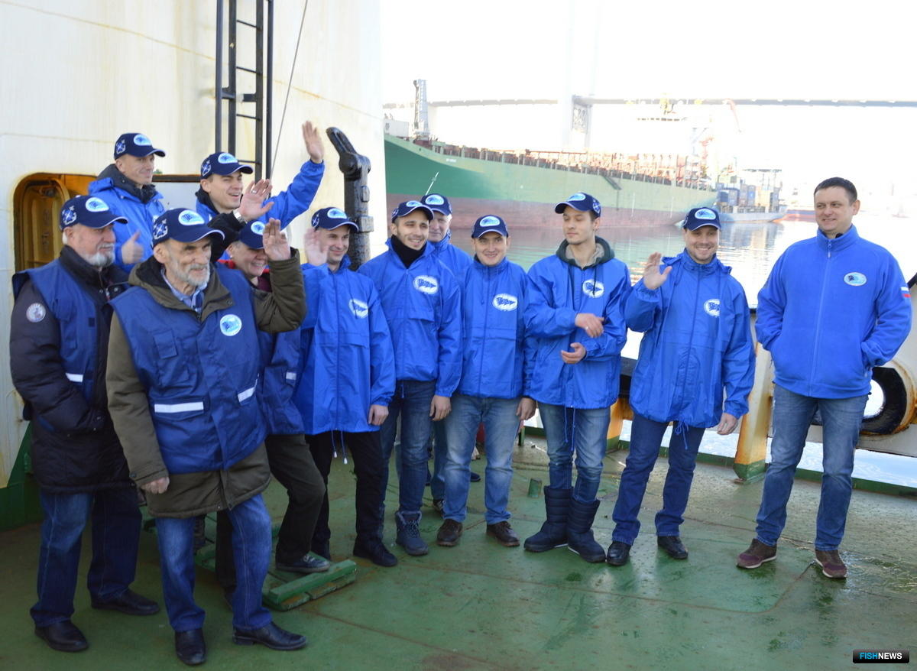
Bridge of the r/v Professor Kaganovskiy
